**Topics: Confidence Intervals**

1. For each of the following statements, indicate whether it is True/False. If false, explain why.
2. The sample size of the survey should at least be a fixed percentage of the population size in order to produce representative results.
3. The sampling frame is a list of every item that appears in a survey sample, including those that did not respond to questions.
4. Larger surveys convey a more accurate impression of the population than smaller surveys.

## Ans 1.True

2. False

3. True

:-

1.  True: The representation of the survey results should have a sample size. The sample size must be a fixed percentage of the total population size of the survey.

2. False: The sampling frame refers to a list of an item which responds to the question and not the ones which do not respond to the questions.

3. True: The larger conveys a more accurate impression of the population as larger surveys involve large sample size which reduces the chances of error.

1. *PC Magazine* asked all of its readers to participate in a survey of their satisfaction with different brands of electronics. In the 2004 survey, which was included in an issue of the magazine that year, more than 9000 readers rated the products on a scale from 1 to 10. The magazine reported that the average rating assigned by 225 readers to a Kodak compact digital camera was 7.5. For this product, identify the following:
2. The population

Ans p=x/n=225/9000=0.025

1. The parameter of interest

Ans  sample size,average,scale

1. The sampling frame

Ans 9000

1. The sample size

Ans  225

1. The sampling design
2. Any potential sources of bias or other problems with the survey or sample

Ans Marginal error, confidence interval ,confidence level

1. For each of the following statements, indicate whether it is True/False. If false, explain why.
2. If the 95% confidence interval for the average purchase of customers at a department store is $50 to $110, then $100 is a plausible value for the population mean at this level of confidence.

Ans The statement is true. If the 95% confidence interval for the average purchase of customers at a department store is $50 to $110, it means that we are 95% confident that the true population mean purchase amount falls within this interval.

1. If the 95% confidence interval for the number of moviegoers who purchase concessions is 30% to 45%, this means that fewer than half of all moviegoers purchase concessions.

Ans So we are certain with a 95% confidence limit for the minimum proportion of moviegoers, who do not purchase from the concession is ( 100 − 45 ) % = 55 % . Since the proportion of moviegoers, who do not like to purchase from the concession is more than 50%, the stated claim is found to be false.

1. The 95% Confidence-Interval for *μ* only applies if the sample data are nearly normally distributed.

Ans False: With a large enough sample, the central limit theorem implies a normal sampling distribution regardless of the distribution of the data.

1. What are the chances that ?
2. ¼
3. ½
4. ¾
5. 1

Ans :-C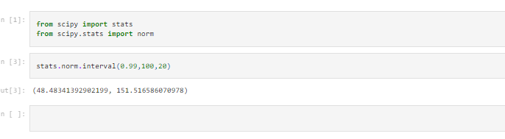

1. In January 2005, a company that monitors Internet traffic (WebSideStory) reported that its sampling revealed that the Mozilla Firefox browser launched in 2004 had grabbed a 4.6% share of the market.
2. If the sample were based on 2,000 users, could Microsoft conclude that Mozilla has a less than 5% share of the market?
3. WebSideStory claims that its sample includes all the daily Internet users. If that’s the case, then can Microsoft conclude that Mozilla has a less than 5% share of the market?

Ans

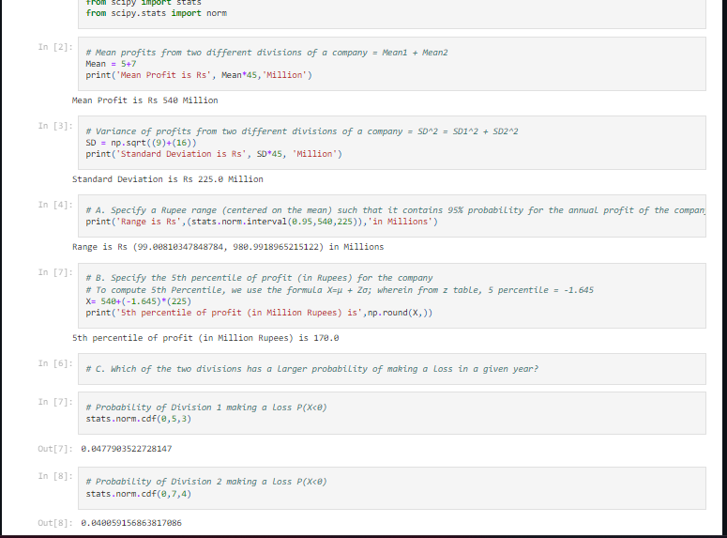

1. A book publisher monitors the size of shipments of its textbooks to university bookstores. For a sample of texts used at various schools, the 95% confidence interval for the size of the shipment was 250 ± 45 books. Which, if any, of the following interpretations of this interval are correct?
2. All shipments are between 205 and 295 books.
3. 95% of shipments are between 205 and 295 books.
4. The procedure that produced this interval generates ranges that hold the population mean for 95% of samples.
5. If we get another sample, then we can be 95% sure that the mean of this second sample is between 205 and 295.
6. We can be 95% confident that the range 160 to 340 holds the population mean.

Ans If we get another sample, then we can be 95% sure that the mean of this second sample is between 205 and 295.

1. Which is shorter: a 95% *z*-interval or a 95% *t*-interval for *μ* if we know that σ =s?
2. The z-interval is shorter
3. The t-interval is shorter
4. Both are equal
5. We cannot say

Ans :- C

Questions 8 and 9 are based on the following: To prepare a report on the economy, analysts need to estimate the percentage of businesses that plan to hire additional employees in the next 60 days.

1. How many randomly selected employers (minimum number) must we contact in order to guarantee a margin of error of no more than 4% (at 95% confidence)?
2. 600
3. 400
4. 550
5. 1000

Ans :- B

1. Suppose we want the above margin of error to be based on a 98% confidence level. What sample size (minimum) must we now use?

Ans :-

1. 1000
2. 757
3. 848
4. 543

Ans :- D